Project Overview-
Material Description
- Details of the individual modules. May include CAD, wiring diagrams, pseudocode, or other relevant tools
Testing Rig Description

Material Integration
- Should detail how the project is assembled from it modules and components.
Material
The material is designed to be easily placed into the base of a football helmet, replacing the currently used EVA foams. During installation, ensure that all hexagonal shapes are oriented in the same direction to allow for uniform deformation. Additionally, the flat hourglass-shaped side, which is circled below in the provided diagram, should also face the same direction. Currently, the material is secured within the helmet using Velcro. However, future iterations will feature a fabric insert for seamless integration into the helmet’s interior.
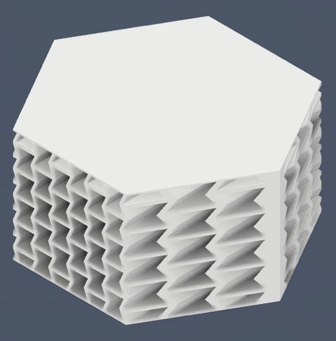

Testing Rig Integration

Material Operation
- This section should show a new user how to safely and effectively use the project you've created.
To ensure proper use, the helmet should be worn according to the manufacturer’s guidelines, such as those outlined by Riddell. The chin strap must be securely fastened to maintain a snug and protective fit.
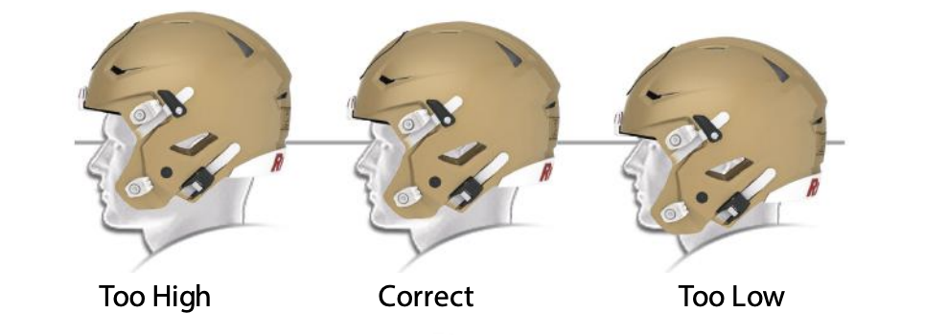
Testing Rig Operation

Material Troubleshooting
If the material inside the helmet breaks or cracks, it should be replaced immediately. If the material becomes loose or detaches from the helmet, it should be repositioned or replaced to maintain proper protection.
Testing Rig Troubleshooting

